CDAC-Mumbai

**Subject: Pattern Challenge in Java**

**Date: 04-09-2024 Total Marks:10**

**Time duration: 40 Min. Batch: August-24**

Q1. Write a Java program to print a hollow pyramid pattern using asterisks (*) and spaces.

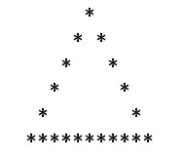

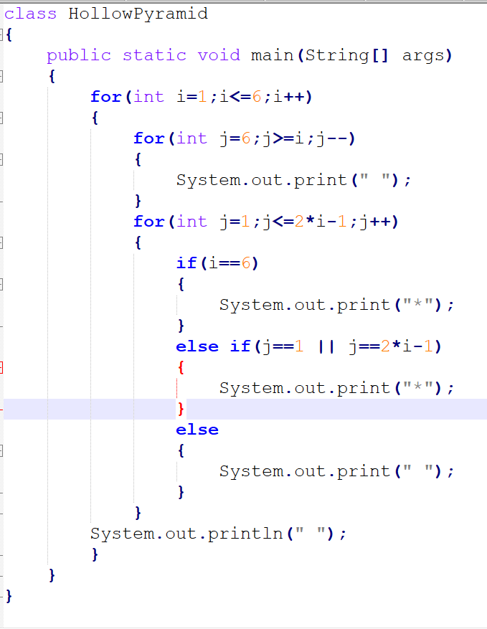

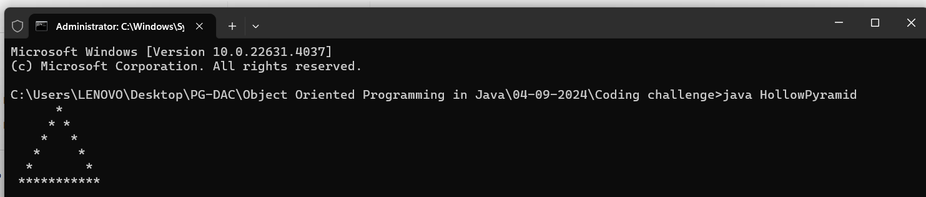

Q2. Write a Java program to print a hollow inverted pyramid pattern using asterisks (*) and spaces.

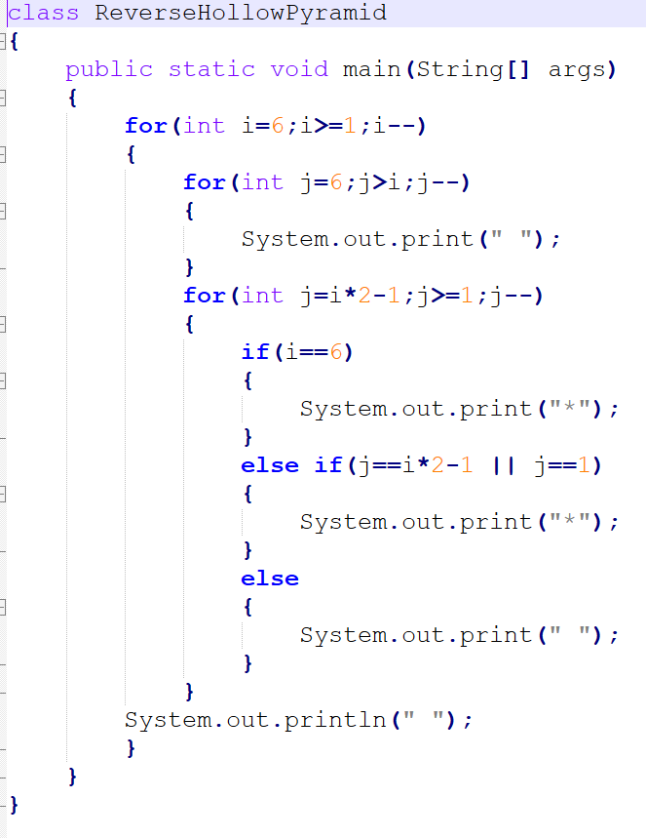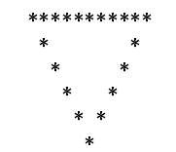

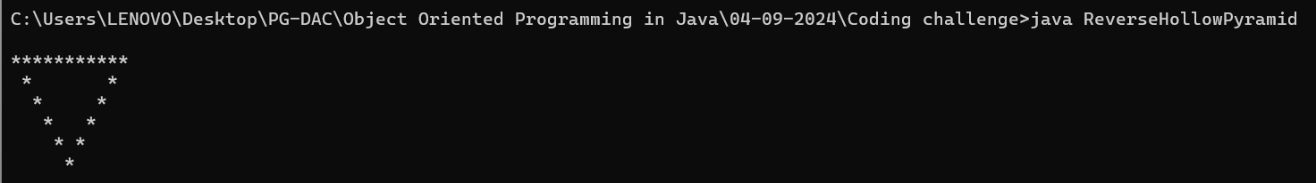

Q3. Write a Java program to print a pyramid pattern of alphabets, starting from 'A', using spaces.

A BCD EFGHI

JKLMNOP QRSTUVWXYZ

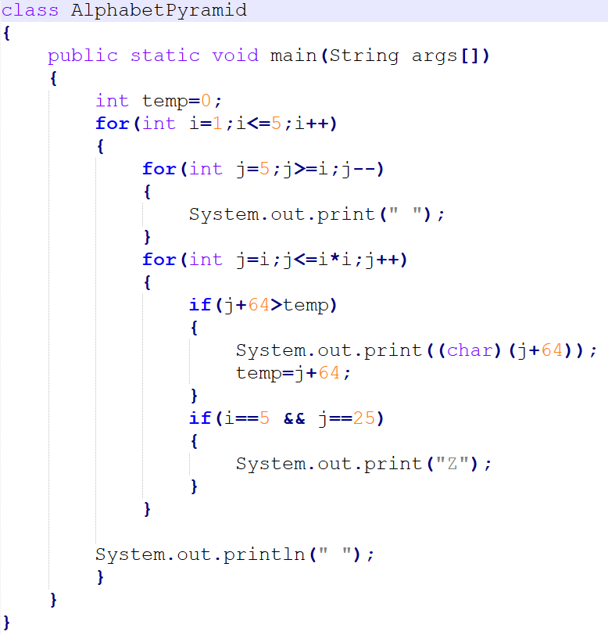

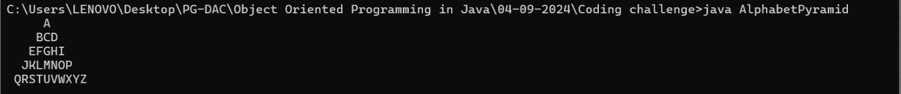

Q4. Write a Java program to print a hollow right triangle pattern using numbers and spaces.

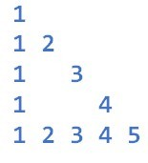

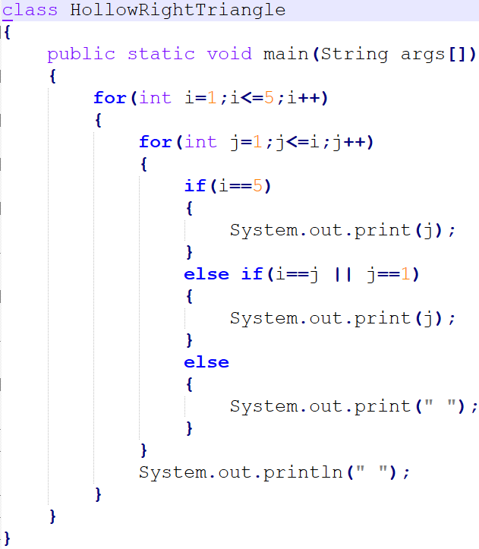

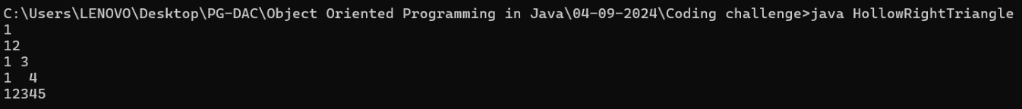

Q5. Write a Java program to print a Palindrome Number Pyramid.

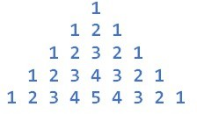

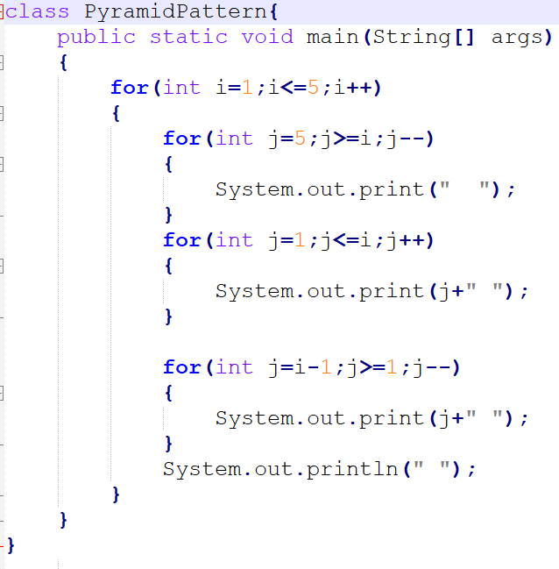

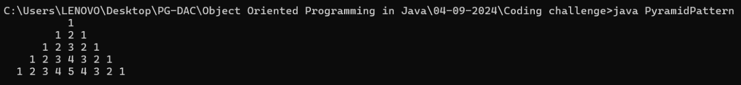

Q6. Write a Java program to print a diamond pattern using numbers.

1

121

12321

1234321

12321

121

1

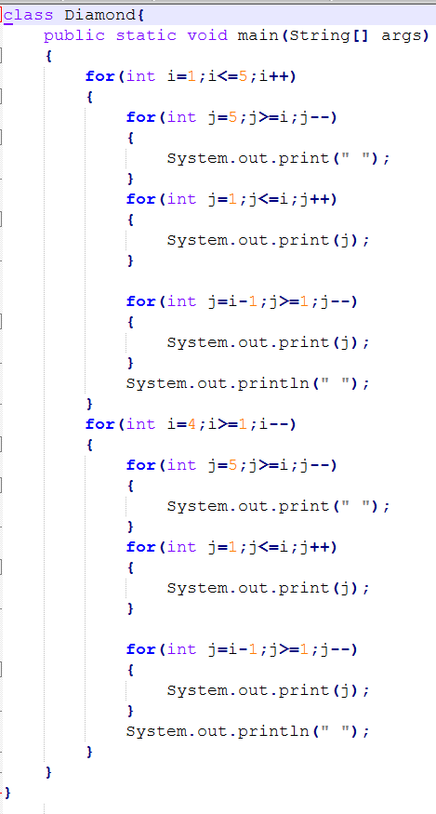

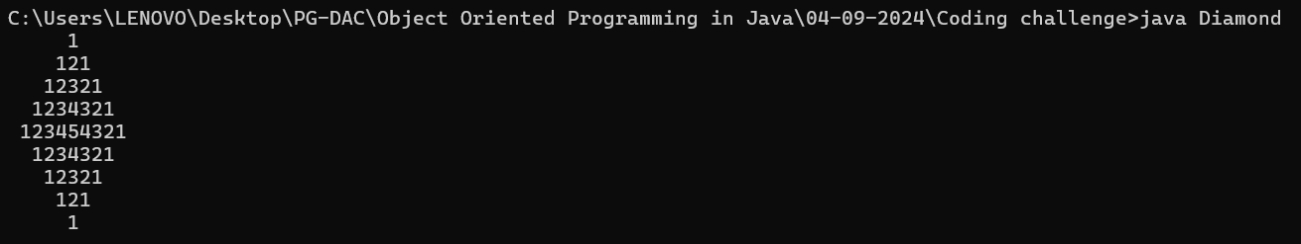

Q7. Write a Java program to print the following pattern using numbers.

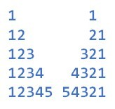

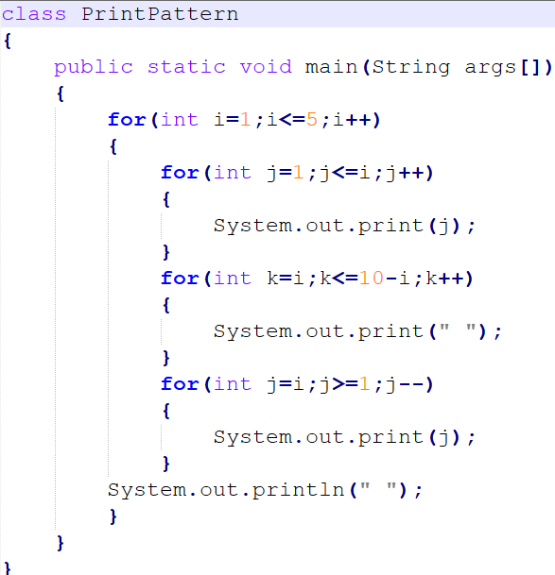

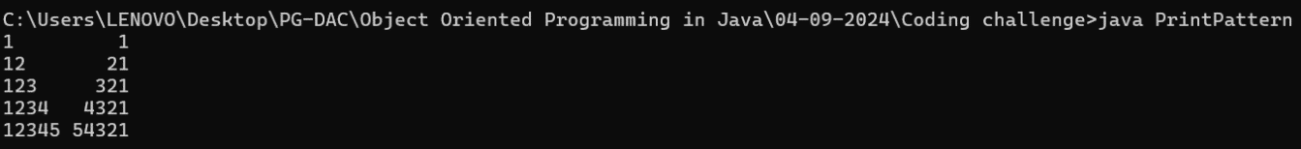

Q8. Write a Java program to print the following pattern using numbers.

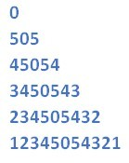

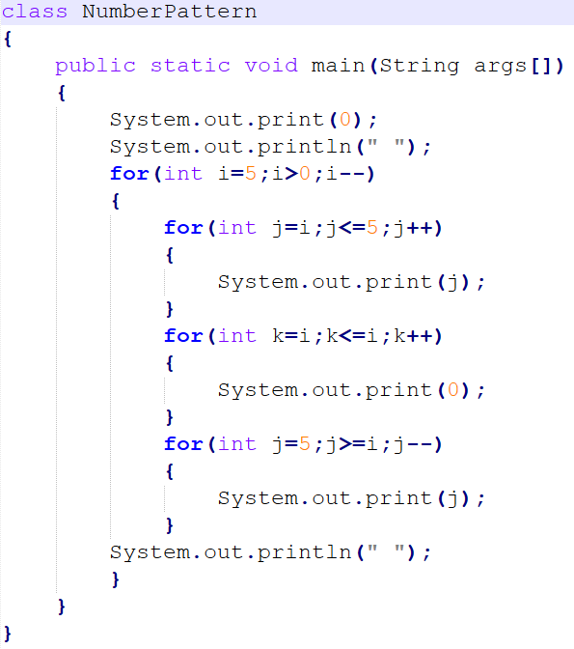

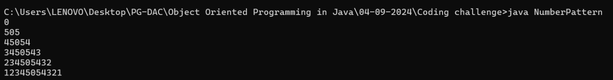

Q9. Write a Java program to print the following pattern using numbers.

1 x 8 + 1 = 9

12 x 8 + 2 = 98

123 x 8 + 3 = 987

1234 x 8 + 4 = 9876

12345 x 8 + 5 = 98765

123456 x 8 + 6 = 987654

1234567 x 8 + 7 = 9876543

12345678 x 8 + 8 = 98765432

123456789 x 8 + 9 = 987654321

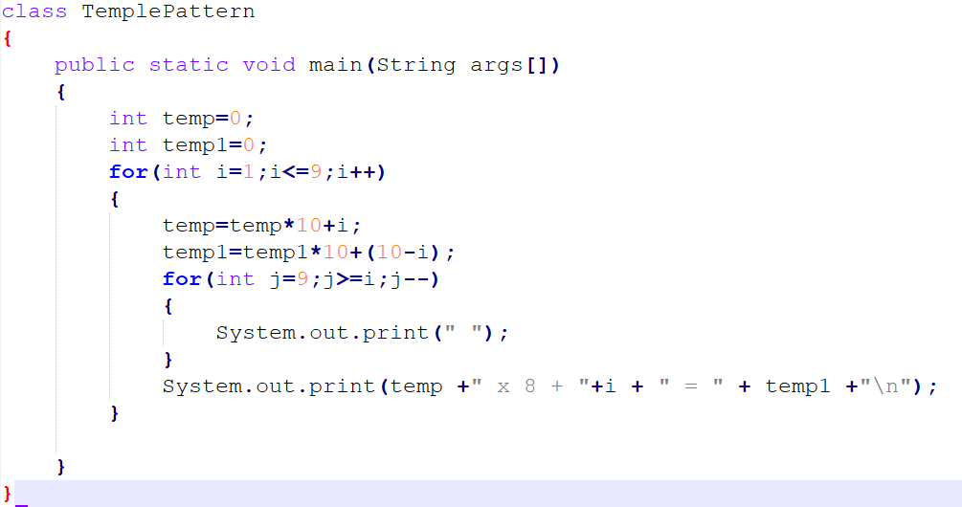

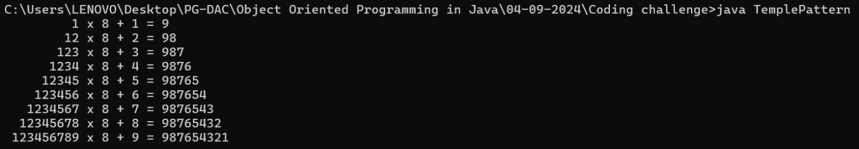

Q10. Write a Java program to print the following pattern using numbers.

